Membership application form

I accept the principles of the National Unmanned Aircraft and Close Sector Cluster and wish to become a member of the cluster. I certify that the following information is correct:

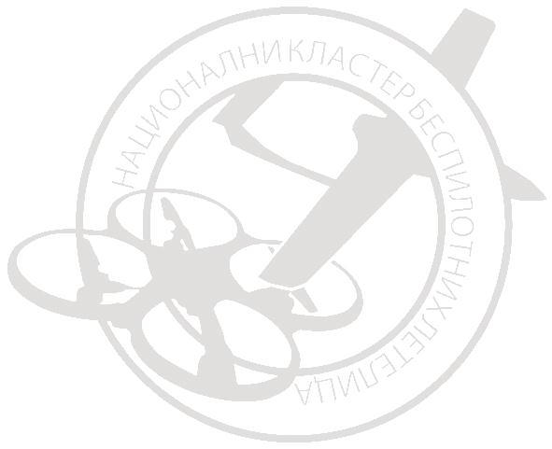
Name and Surname
Unique identification number of citizen or passport number
Address (street, number, postal code, city, state)
Phone-Cellular
E-mail
Private Entity category
UAV - Description
I can contribute to the association | Experience in work improvement, promotion and projects

Date: Signature
________________________ ___________________________

